Imam Abdulrahman Bin Faisal University
College of Computer Science and Information Technology
ARTI406 – Assignment 2
Dataset: Student Admission Records

Student Name: Ghadah Bohliga
Student ID: 2230006953
Submitted to: Dr. Alaa Alahmadi

Task 1 – Data Quality Issues
Screenshots
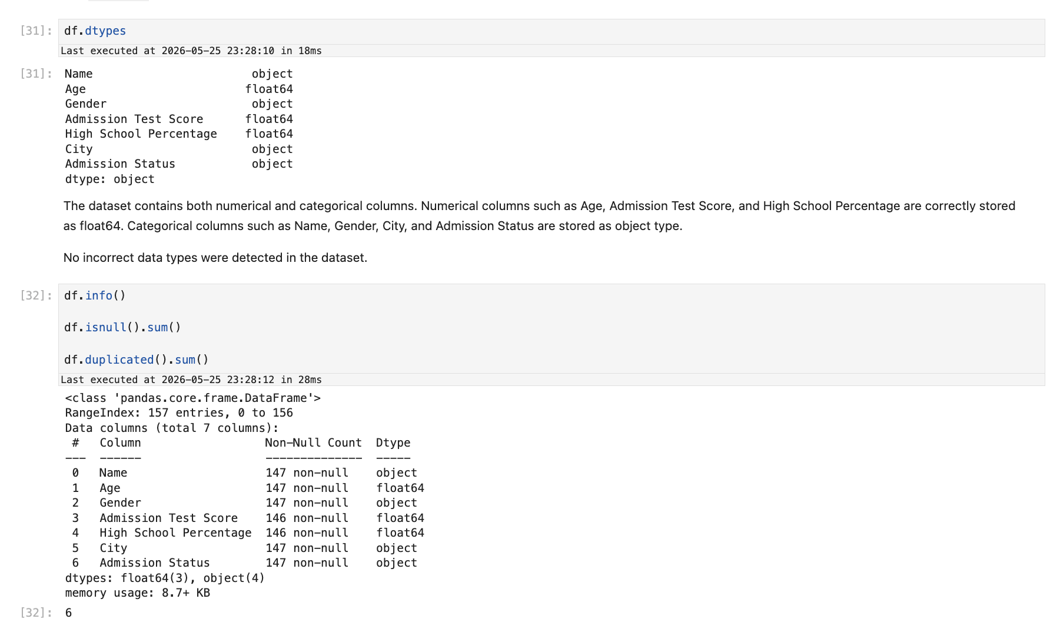

Figure 1.1: Data types and missing values count for each column

Explanation
Explanation
The dataset was examined for three main quality issues:

1. Data Types: All columns have appropriate data types. Numerical columns (Age, Admission Test Score, High School Percentage) are stored as float64, and categorical columns (Name, Gender, City, Admission Status) are stored as object type. No type mismatches were found.

2. Missing Values: Several columns contain missing values in both numerical and categorical fields. Missing values must be handled before any further analysis to avoid biased or incorrect results.

3. Duplicate Records: The dataset contains 6 duplicate rows. Duplicate records can skew analysis results and must be identified and removed to ensure data integrity.

Task 2 – Missing Value Handling
Screenshots
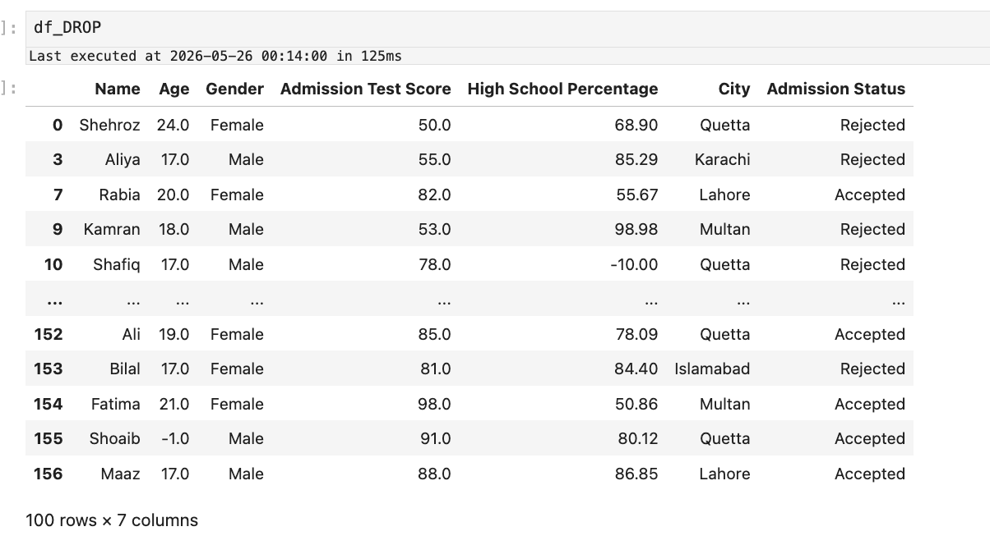
Figure 2.1: Remove Missing Records
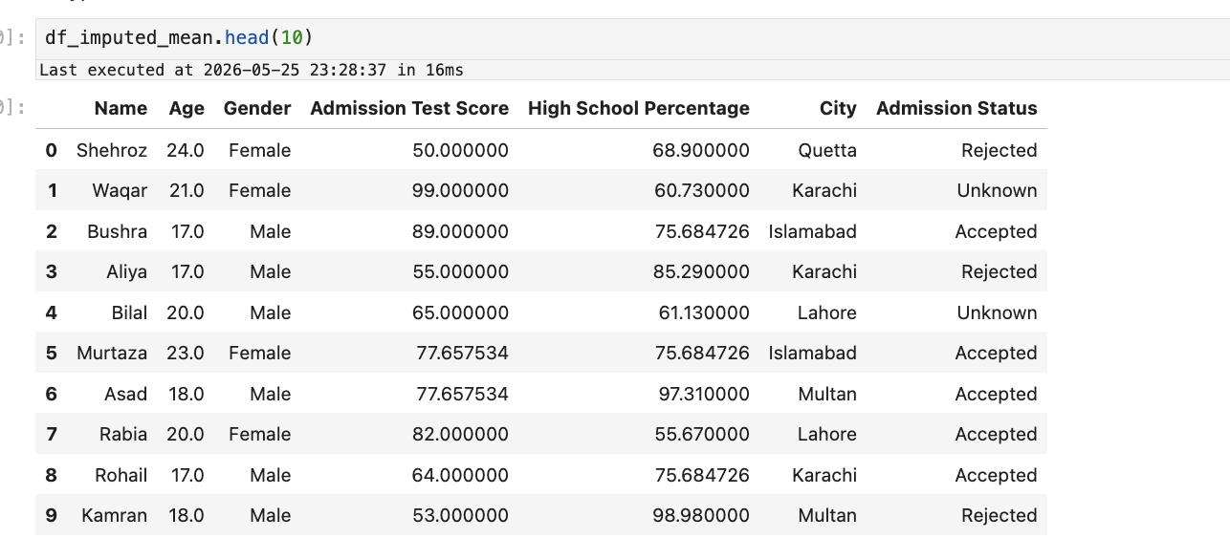
Figure 2.2 Mean Imputation

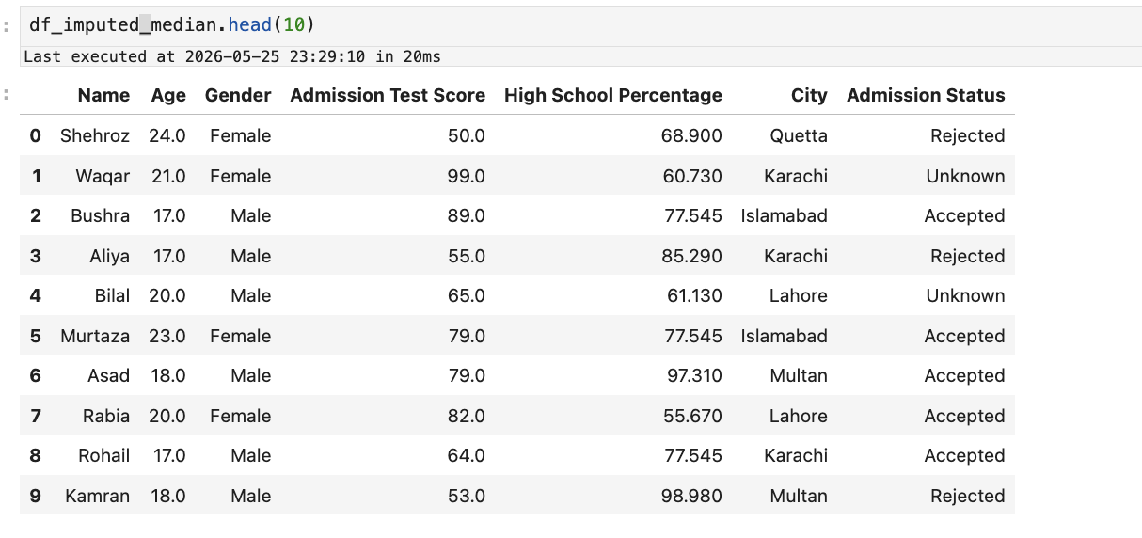
Figure 2.3 Median Imputation

Explanation
Explanation
Missing Value Handling Strategies
Several strategies can be used to handle missing values in a dataset.
Strategy 1: Remove Missing Records
This strategy removes rows that contain missing values using dropna(). Although simple, it may reduce the dataset size and remove useful information.
For example:
- A student record with a missing Admission Test Score would be completely removed from the dataset.

Strategy 2: Mean Imputation
Mean imputation replaces missing numerical values with the average value of the column.
For example:
- Missing values in the Admission Test Score column are replaced with the mean admission score of all students.
This method preserves the dataset size, but the mean can be affected by extreme values.

Strategy 3: Median Imputation (Selected Strategy)
Median imputation replaces missing numerical values with the median value of the column.
For example:
- Missing values in Age, Admission Test Score, and High School Percentage were replaced using their median values.
This strategy was selected because the median is less sensitive to extreme values and provides more reliable preprocessing results.
For categorical columns such as Name, Gender, City, and Admission Status, missing values were replaced with "Unknown" to preserve dataset completeness.
The final preprocessing steps in this assignment were performed using the median-imputed dataset.

Task 3 – Outlier Detection using IQR
Screenshots
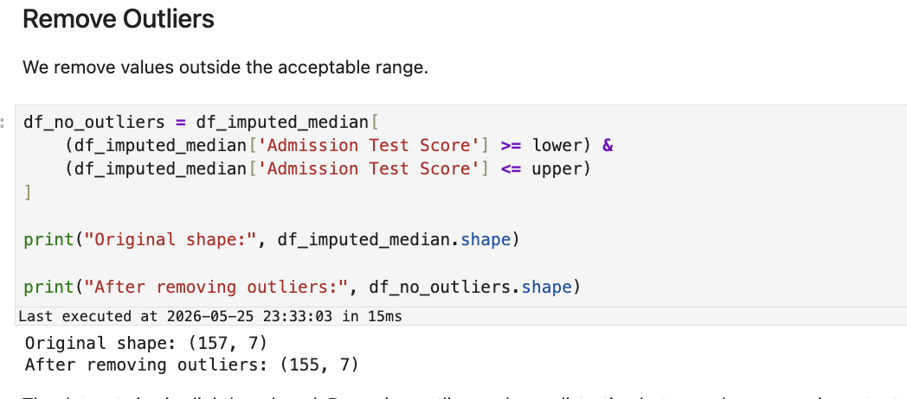
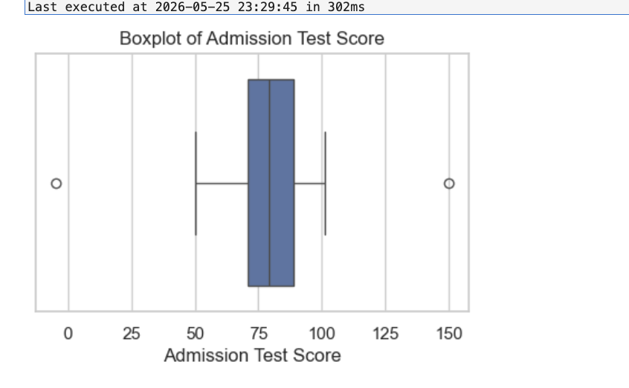
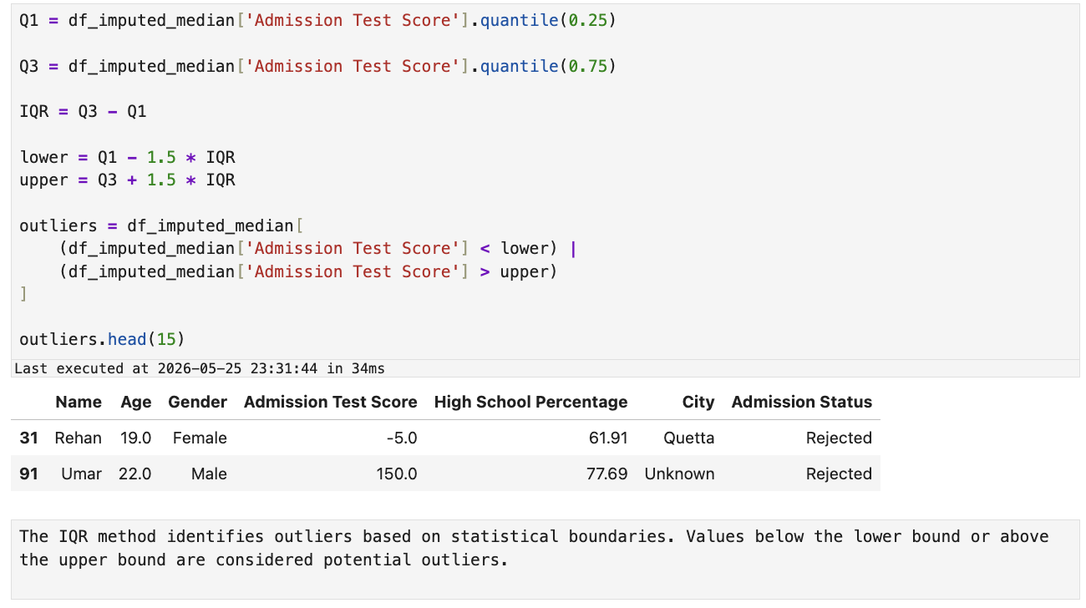
Figure 3.1: Boxplot of Admission Test Score and IQR outlier detection summary

Explanation
Explanation
Method: Interquartile Range (IQR)

The IQR method was used to detect and handle outliers in the Admission Test Score column.

• Q1 (25th percentile) and Q3 (75th percentile) were computed from the data.
• IQR = Q3 − Q1
• Lower Bound = Q1 − 1.5 × IQR
• Upper Bound = Q3 + 1.5 × IQR

Any score below the lower bound or above the upper bound is flagged as an outlier. The boxplot clearly shows points extending beyond the whiskers, confirming the presence of extreme values (e.g., scores of 150 and below 0).

Outlier records were identified and removed, reducing the dataset size slightly. These values appeared to be unusual observations or possible data entry errors, justifying their removal.
Task 4 – Normalization
Screenshots
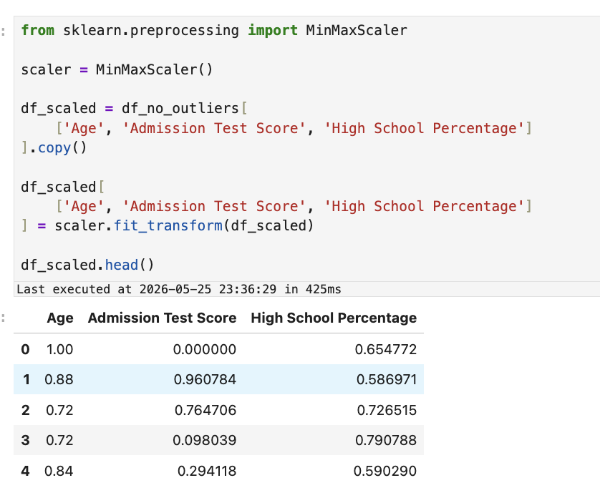
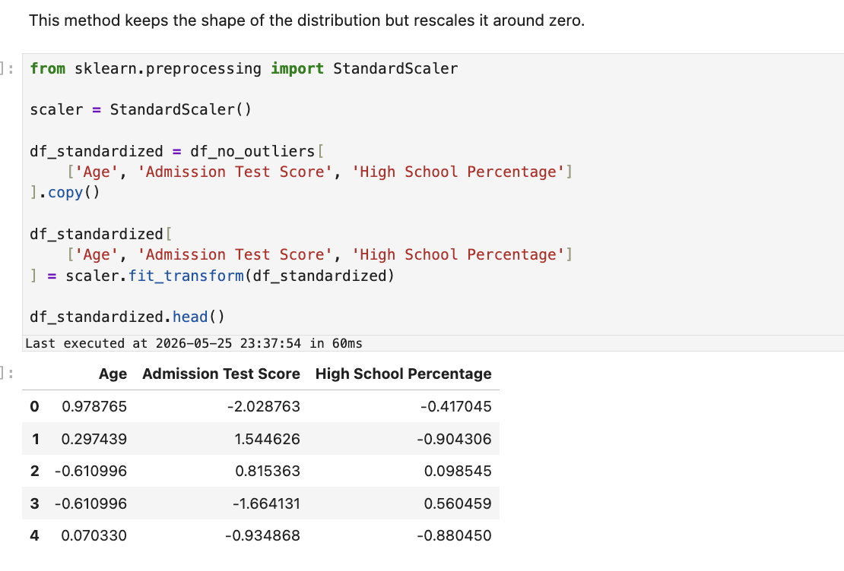
Figure 4.1: Min-Max normalization output (top) and Z-Score normalization output (bottom)
Explanation
Explanation
Two normalization techniques were applied to the numerical features (Age, Admission Test Score, and High School Percentage).

1. Min-Max Normalization:
This method scales numerical values between 0 and 1 using the minimum and maximum values of each feature.

After normalization, all values fall within the range [0, 1], making the features easier to compare.

2. Z-Score Normalization (Standardization):
This method transforms the data so that the mean becomes approximately 0 and the standard deviation becomes approximately 1.

Standardization is useful before applying PCA because it ensures that all numerical features contribute equally to the analysis.

Both normalization methods help improve preprocessing quality and reduce the effect of differences in feature scales.
Both methods make the numerical features comparable regardless of their original units or scales, preventing any single feature from dominating model training.

Task 5 – PCA (Principal Component Analysis)
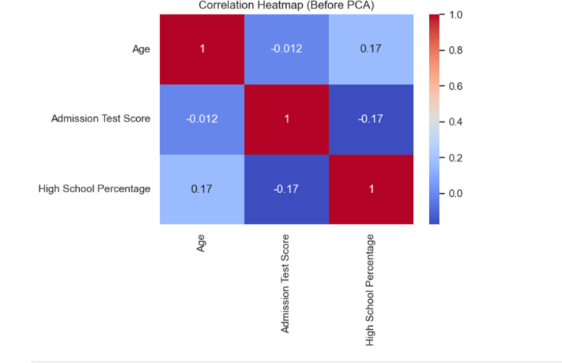
Screenshots

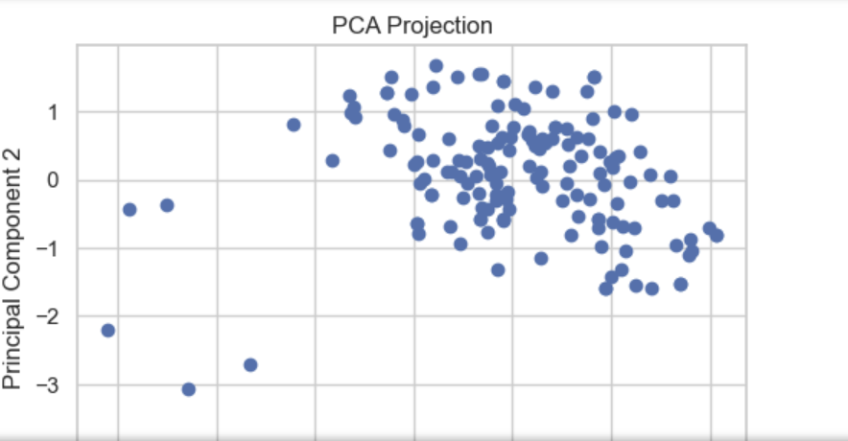
Figure 5.2: heatmap before PCA, explained variance ratio, and PCA projection scatter plot
Explanation
Explanation
Principal Component Analysis (PCA) was applied to reduce the dimensionality of the standardized numerical features.
Steps performed:
• The correlation heatmap was examined first. The features show weak correlations, indicating limited overlap in information.
• PCA with 2 components was applied to the standardized dataset (Age, Admission Test Score, and High School Percentage).
Results:
• Principal Component 1 (PC1) captures approximately 41.6% of the total variance.
• Principal Component 2 (PC2) captures approximately 32.9% of the total variance.
• Together, the two components retain about 74.5% of the original information while reducing 3 features down to 2.
The PCA scatter plot shows the student records projected into the new 2D space. PCA successfully reduces dimensionality while preserving most of the important information from the original dataset.

